Intrusion Detection System

A PROJECT REPORT

Bachelor of Technology in
COMPUTER ENGINEERING

Major Project I (01CE0716)

Submitted by

AUMANSH VIJAYENDRA GUPTA
92200103209

SACHIN KUMAR AMAN
92200103259

RADHIKA KETANBHAI PITHVA
92200103283



Faculty of Engineering & Technology Marwadi University, Rajkot

August, 2025




Major Project I (01CE0716) Department of Computer Engineering Faculty of Engineering & Technology Marwadi University

A.Y. 2025-26

CERTIFICATE

This is to certify that the project report submitted along with the project entitled Intrusion Detection System has been carried out by Aumansh Vijayendra Gupta (92200103209), Sachin Kumar Aman (92200103259), Radhika Ketanbhai Pithva (92200103283) under my guidance in partial fulfilment for the degree of Bachelor of Technology in Computer Engineering, 7th Semester of Marwadi University, Rajkot during the academic year 2025-26.

Dr. Anjali Diwan Dr. Krunal Vaghela

Associate Professor Professor & Head

Department of Computer Engineering Department of Computer Engineering




Major Project I (01CE0716) Department of Computer Engineering Faculty of Engineering & Technology Marwadi University

A.Y. 2025-26

CERTIFICATE

This is to certify that the project report submitted along with the project entitled Intrusion Detection System has been carried out by Aumansh Vijayendra Gupta (92200103209) under my guidance in partial fulfilment for the degree of Bachelor of Technology in Computer Engineering, 7th Semester of Marwadi University, Rajkot during the academic year 2025-26.

Dr. Anjali Diwan Dr. Krunal Vaghela

Associate Professor Professor & Head

Department of Computer Engineering Department of Computer Engineering




Major Project I (01CE0716) Department of Computer Engineering Faculty of Engineering & Technology Marwadi University

A.Y. 2025-26

CERTIFICATE

This is to certify that the project report submitted along with the project entitled Intrusion Detection System has been carried out by Sachin Kumar Aman (92200103259) under my guidance in partial fulfilment for the degree of Bachelor of Technology in Computer Engineering, 7th Semester of Marwadi University, Rajkot during the academic year 2025-26.

Dr. Anjali Diwan Dr. Krunal Vaghela

Associate Professor Professor & Head

Department of Computer Engineering Department of Computer Engineering




Major Project I (01CE0716) Department of Computer Engineering Faculty of Engineering & Technology Marwadi University

A.Y. 2025-26

CERTIFICATE

This is to certify that the project report submitted along with the project entitled Intrusion Detection System has been carried out by Radhika Ketanbhai Pithva (92200103283) under my guidance in partial fulfilment for the degree of Bachelor of Technology in Computer Engineering, 7th Semester of Marwadi University, Rajkot during the academic year 2025-26.

Dr. Anjali Diwan Dr. Krunal Vaghela

Associate Professor Professor & Head

Department of Computer Engineering Department of Computer Engineering




Major Project (01CE0716) Department of Computer Engineering Faculty of Engineering & Technology Marwadi University

A.Y. 2025-26

DECLARATION

We hereby declare that the Major Project-I (01CE0716) report submitted along with the Project entitled Intrusion Detection System submitted in partial fulfilment for the degree of Bachelor of Technology in Computer Engineering to Marwadi University, Rajkot, is a bonafide record of original project work carried out by me / us at Marwadi University under the supervision of Dr. Anjali Diwan and that no part of this report has been directly copied from any students’ reports or taken from any other source, without providing due reference.

S.No Student Name Sign
Aumansh Vijayendra Gupta
1
aumansh.gupta119560@marwadiuniversity.ac.in
Sachin Kumar Aman
2
sachinkumaraman.118206@marwadiuniversity.ac.in
Radhika KetanBhai Pithva
3
radhika.pithva120061@marwadiuniversity.ac.in

Acknowledgement
We would like to express our heartfelt gratitude to everyone who contributed to the successful completion of this project, “Intrusion Detection System”.

First and foremost, we extend my sincere appreciation to our guide Prof. Dr. Anjali Diwan for their invaluable guidance, continuous support, and encouragement throughout the project. Their expert insights and constructive feedback have greatly enhanced our understanding of the subject.

We would also like to thank Marwadi University for providing us with the necessary resources, facilities, and academic support to carry out this research effectively.

A special note of appreciation goes to our peers and fellow researchers for their constructive discussions and encouragement, which helped refine our approach.

Lastly, we extend our gratitude to our families and friends for their unwavering support, patience, and motivation throughout this journey.

This project has been a great learning experience, and we hope that our findings contribute to further advancements in traffic forecasting and intelligent transportation systems.

ABSTRACT

Abstract
The growing concerns of unauthorized access in secure organizations is still going on and there is a need for an intelligent system that can detect intruders in real time. This project proposes a hybrid system for detection of intrusions combining speed and efficiency of Convolution neural network and Linear Binary Pattern Histogram for the classification of weapons and crowd by using the CrowdHuman and Open V6 Images Dataset so that for once the system will determine from the image whether the image of that person in it is having a suspicious or is a normal person so that our model will be taking care to make decisions accordingly whether the intruder is having weapon or not. System is being trained and evaluated using CrowdHuman to detect humans and OpenV6 Gun dataset to handle scenarios involving potential threats. The results which are the best is YOLO+LBPH+CNN with an accuracy of 70%. We compared it with YOLO+CNN but we got 68%. So the final method which we had proposed is YOLO+LBPH+CNN. It allows robust classification even in challenging scenarios such as lighting, exposure and crowded scenes. Results are accurate than the older systems which are being proposed by other authors.

LIST OF FIGURES

List of Figures
Fig 3.1 YOLO+CNN 7
Fig 3.2 YOLO+LBPH+CNN 9
Fig 3.3 Finalized Methodology 10
Fig 4.1 CrowdHuman Person detect 12
Fig 4.2 OpenV6Images Weapon detect 12
Fig 4.3 Results with the Combining two dataset 12
Fig 4.4 Normal vs Suspicious in the image 15

LIST OF TABLES

List of Tables

Table 4.1 Classification Report of YOLO+CNN 13
Table 4.2 Classification Report of YOLO+LBPH+CNN 14

ABBREVIATIONS

Abbreviations

LBPH Local binary pattern histogram CNN Convolution neural network
YOLO You look only once
IPHMOM Investigation on the Performance of the Hybrid Model and Overfitting Mitigation DSISP Detection Scenario Interpretation and System Performance

TABLE OF CONTENTS

Table of Contents

ACKNOWLEDGEMENT | PAGE NO.  VII
ABSTRACT | VIII
LIST OF FIGURES | IX
LIST OF TABLES | X
ABBREVIATIONS | XI
TABLE OF CONTENTS | XII
1. INTRODUCTION | 1
1.1 INTRODUCTION | 1
1.2 SYSTEM OVERVIEW | 2
2. LITERATURE REVIEW | 3
3. RESEARCH METHODOLOGY | 5
3.1 DATASET DESCRIPTION | 5
3.2 YOLO | 6
3.3 CNN | 6
3.4 LBPH | 8
3.5 PROPOSED METHODOLOGY | 10
4. RESULTS & DISCUSSIONS | 11
4.1 IMAGES PERSON DETECT AND WEAPON | 11
4.2 YOLO+CNN | 13
4.3 YOLO+CNN+LBPH | 14
4.4 IPHMOM | 14
4.5 DSISP | 15
4.6 COMPARE METHODOLOGY & SHOW RESULT | 16
5. CONCLUSION | 18
5.1 CONCLUSION | 18
5.2 LIMITATION AND FUTURE WORK | 18
REFERENCES | 20

CHAPTER 1 INTRODUCTION

Introduction

In a time when security threats are on a constant rise, there is a greater need for sophisticated surveillance systems today than ever before. Conventional security infrastructures, commonly based on passive Closed-Circuit Television (CCTV) solutions, are no longer effective in inhibiting unlawful access and violent outbreaks insecured locations like banks, business offices, and public buildings. These conventional solutions are usually in the form of post-incident recording tools with minimal real-time threat detection and active intervention capability. Limitations in human surveillance such as fatigue, distraction, and information overflow by virtue of competing multiple camera feeds make a shift towards smart, automatic surveillance solutions a requirement.
The core problem addressed by this project is the urgent need for a system that can not only monitor secure areas but also intelligently identify potential threats in real time, enabling swift and preventive action. The societal importance of such technology is underscored by the pressing need for enhanced safety measures in public spaces like schools, airports, and transportation hubs, where the potential for harm is significant.4 This project, therefore, moves beyond simple monitoring to develop a proactive intrusion detection system. It aims to automate the identification of suspicious individuals and potential weapons, thereby augmenting the capabilities of security personnel and creating safer environments. The motivation is to bridge the gap between passive observation and active threat mitigation by leveraging state-of-the-art deep learning and computer vision techniques.
This project proposes a novel, hybrid Intrusion Detection System designed to address the dual challenges of speed and accuracy in real-time surveillance. The system is architecturally designed as a modular, two-stage pipeline that synergistically combines the strengths of multiple computer vision models. The first stage employs the You Only Look Once version 8 (YOLOv8) object detection model for rapid and efficient localization of persons and potential weapons within a video frame. The second stage utilizes a sophisticated behavior classification model that fuses features from a Convolutional Neural Network (CNN) with texture descriptors from Local Binary Pattern

Histograms (LBPH) to analyze the detected individuals. This hybrid approach is predicated on the principle of leveraging distinct models for their specialized strengths: YOLOv8 for its high-speed detection capabilities and the CNN+LBPH classifier for its nuanced and robust feature extraction for classification tasks.

System Overview
This system design is an intricate engineering solution for an inherently intricate challenge. Deploying a computationally burdensome classifier on a complete high- resolution video frame would not be feasible for real-time operation. However, the YOLOv8 detector operates as a smart "attention mechanism." It quickly surveys the frame and winnows the tremendous amount of visual information down to just those most salient regions of interest—the detected persons' bounding boxes.8 Doing so makes it possible to use only where needed a more powerful and resource-hungry CNN+LBPH classifier while still allowing a system fast enough for real-time use yet accurate enough for effective threat assessment.
The main objectives for this project are thus defined as:
To implement and execute a modular pipeline for people and possible weapons detection from live video streams based on the YOLOv8 algorithm.
To develop and train a hybrid classifier model which is a combination of hand-crafted texture features in LBPH as well as deep features in a CNN for effective classification of detected people as 'Authorized/Normal' or 'Intruder/Suspicious'.
To perform a comparison study between proposed hybrid model and other alternative architectures based on investigating model generalization in order to curb overfitting common issue.
To generate a concluding system which achieves a balance between high accuracy and computational effectiveness while ensuring its applicability for real applications in realistic security scenarios.

CHAPTER 2 LITERATURE REVIEW
Through so many papers, we studied the intrusion detection using PCA which is done by Rodelas N et al. [1] and we can say that in the paper itself whatever they have used the dataset and made up to 93% accuracy, but they do not have a working in real time dataset. The paper of Wang Z. et al. [2] in which they proposed Convolutional SNN, but the problem is that CNN outperforms their hybrid model, and the experiment are being conducted only on public datasets and no more evaluation of diverse dataset and there was a hardware dependency, so it is unclear how model performs on actual edge devices. In another paper of Esmaily J. et al. [3] the methods were of the Random Forest Decision Tree and the simple multi-layer perceptron method on KD Cup 99 Dataset, but the limitation is they have an offline system where they designed and tested, that means it does not process live traffic, plus no demonstration of real time capability.
In the paper of Talib M et al. [4] where they have used deep learning to detect multi weapons and they have used their self-curated dataset and used YOLOv7 (You Look Only Once) & CNN (Convolution Neural Network) , but the limitations were the lack of focus on weapon types, no in-depth analysis of False Positives and Negatives.
The next paper which is about Shao S et al. [5] A benchmark for detecting human in crowd where they have used Faster RCNN and FPN which serves the main part of detecting visible body but can introduce domain bias, no fined grained identity labels and occlusions remain extremely challenging.
Some recent publications explored real-time intrusion detection by means of deep learning. As an illustration, Bhamare et al. (2022) presented a "Smart Intruder Detection System" which is fitted with a CNN for threat detection and intruder detection as well as YOLO (You Only Look Once) for guns detection [6].
Their computer-vision pipeline (OpenCV + CNN + YOLO) was very accurate for detection of weapons and intruders in CCTV footage. Moreover, Pavithra et al. (2023) employ a pre-trained model of YOLO (which is trained on MS-COCO) for real-time detection of theft by resizing and normalizing frames for increased real-time effectivenessthese. These YOLO-type solutions demonstrate how you can very rapidly identify objects (e.g. people, guns) in pictures in order to support rapid intrusion

detection. To perform on high-definition video in real-time, though, you might need robust edge hardware.
Another component is face recognition for validating whether a detected face is allowed. Several such systems use the Local Binary Pattern Histogram (LBPH) method for this. Sanjay and Deva Priya in a comparison between CNN and LBPH for crime face recognition concluded that LBPH was slightly more precise.
They argue that computational efficiency and lighting robustness of LBPH render it suitable for surveillance. Raghupathy et al. demonstrate in action: in their smart security camera system augmented by YOLO, they "employed the Local Binary Pattern Algorithm (LBPH) detection and identification [of faces] for distinguishing between unauthorized people and legitimate users[7]. In fact, their paper describes cutting recognition time considerably while tolerating only minimal accuracy loss when applying LBPH[8].
Likewise, Bhuckory and Pudaruth et al. describe a Raspberry-Pi–based home security prototype using a combination of CNNs and LBPH for face authentication. Their system retrains neural networks on known faces and uses LBPH for low-power on-device matching: “The system uses a combination of neural networks and the Local Binary Patterns Histogram (LBPH) model to have a good accuracy level… LBPH requires low computing power and is thus suitable for Raspberry Pi microcontrollers”[9].
These papers confirm the validity of LBPH in learned-intruder detection when training samples or resources are limited.Scientists also examine hybrid approaches such as YOLO object detection and face recognition based on LBPH/CNN. Another such technique is recognition of a person in a frame based on YOLO detection with subsequent use of a face-recognition program. A YOLO-based system, for instance, would identify a person based on YOLO detection and then apply LBPH to a face cut out for identity verification[10]. If the face does not match any registered user, the system flags an intrusion. This pipeline leverages YOLO’s speed and LBPH’s efficiency to operate in real time on edge devices. However, challenges remain (e.g. handling occlusions and diverse angles). In general, deep CNN backbones (like those in YOLO) tend to yield higher accuracy than LBPH but require more computation. The literature emphasizes the need for balanced designs: fast object detection for intruder presence, combined with lightweight face recognition for identification[9][10].

CHAPTER 3 RESEARCH METHODOLOGY
The system proposed uses a holistic hybrid model intended to take full advantage of the best features of several state-of-the-art computer vision approaches. Architecture is based on a synergistic pipeline consisting of rapid object detection combined with strong, multi- modal feature extraction for proper behaviour classification. This option was made in order to develop a system both effective in its classification capabilities as well as computationally feasible for real-time surveillance use. Central to its methodology is its YOLO+CNN+LBPH framework. This architecture uses YOLOv8 for its best-of-class speed and accuracy in object detection for people and weapons. Once detected, a hybrid feature fusion method is used for classification. This consists of a combination of a CNN's hierarchical, abstract visual features learned for a subject with Local Binary Pattern Histograms (LBPH)'s fine-grained, illumination-invariant texture information. This fusion of learned and hand-designed features generates a very descriptive representation of its subject such that a more robust and generalizable model is developed for classification. Another hybrid method in a YOLO framework involving a combination or integration for a deep network with an LBP layer within a detection framework has been shown in other detection tasks involving greater difficulty to succeed as a strong precedent for this methodological selection.

DATASET DESCRIPTION:
CrowdHuman Dataset: It is a large-scale test dataset exclusively for pedestrian detection in extremely crowded scenes. It includes detailed annotations for full bodies, occluded/visible body parts, as well as head-oriented bounding boxes. Its contribution is essential in training a person detector robust even in real-world environments with heavy occlusion and diverse human poses.
OpenImages V6 Dataset: It is a large, variform dataset which comprises millions of images annotated with thousands of object classes. There is a subset of this dataset which is specifically annotated with weapons such as guns and knives. It was employed for training a model for detection of weapons. Due to its sheer richness in object appearances, background variations, and lighting conditions, there is a need for this dataset for creating a generalizable detector for weapons.

YOLO
The first and most essential phase in the system pipeline is object detection and localization within the video stream. For this purpose, the YOLOv8 model was chosen. As the most recent successor in the You Only Look Once lineages, YOLOv8 achieves a remarkable balance between ultrafast speed and detection performance and is thus a prime candidate for real-time detection for weapons as well as people tracking.4 The basic concept behind the YOLO design is its single-shot capability; it analyzes a full image in a single forward neural network pass while predicting all bound boxes as well as class confidence in parallel. That is in comparison with slow two-stage detectors and is key in enabling the low latency needed for real-time surveillance.
YOLOv8 architecture is made up of three components:
Backbone: A CNN at a deeper level which learns a rich hierarchy of features at multiple scales in the input image.
CERVICAL: A sequence of layers like a Feature Pyramid Network (FPN), which collect and pool features at multiple stages in a backbone. It allows for efficient object detection at a range of scales.
Head: Last element in the network which makes prediction based on combined features and returns objectness score, class probabilities for detected objects, and coordinates for bounding box.
To ensure specialized and accurate detection, two separate YOLOv8n models were trained. The 'n' variant (nano) was chosen for its lightweight architecture, which further enhances processing speed. The first model was trained on the large-scale CrowdHuman dataset for the specific task of person detection, enabling it to perform robustly even in crowded and occluded scenes. The second model was trained on a curated subset of the OpenImages V6 dataset to detect potential weapons, such as guns and knives. This two- model approach allows each detector to become highly specialized, improving the overall accuracy of the initial detection stage. Once an object is detected, the model outputs its bounding box coordinates, defined as b=(x,y,w,h), where (x,y) are the center coordinates and (w,h) are the width and height, respectively.

CNN
After a successful detection of an individual by YOLOv8, a region specified by the bounding box is trimmed from the original frame. This trimmed image which separates an individual of interest is further sent for behavior classification. The main constituent

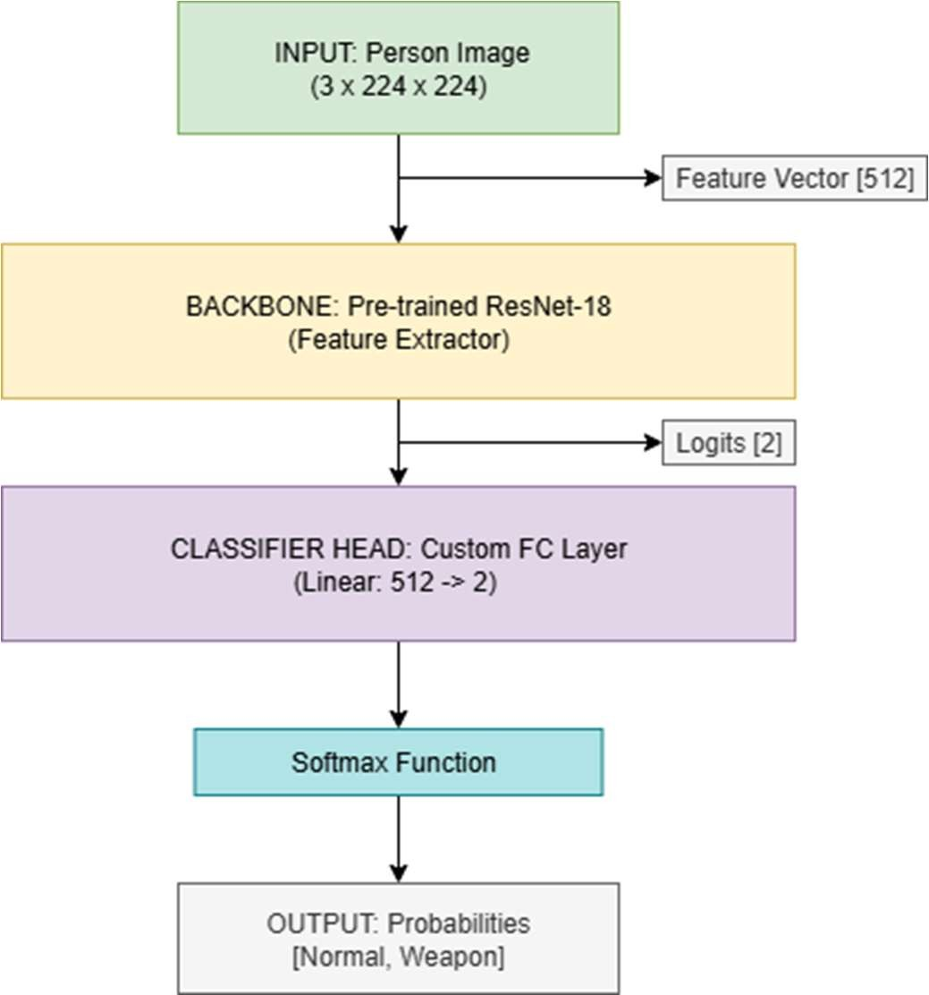
of this is a Convolutional Neural Network (CNN), a type of deep neural network expressly created for processing and visual imagery analysis.
FIGURE 3.1: YOLO+CNN

Preprocessing is first applied to the person crop image by resizing it to a fixed size of 224×224 pixel and scaling up the pixel intensity values between 0 to 1. This is accomplished by dividing pixel intensity value I by 255, as in Equation (i):

𝐼norm
= I 255
(i)

Normalized image is then fed into CNN. We take a ResNet18 model as our backbone for our project. Major components in our network operate in the following sequence 23: Convolutional Layers: These layers apply a series of learnable filters (kernels) on the input image, producing feature maps which recognize low level features like edges and texture in early layers, and high level abstract features like shapes and object parts in later layers. We can define its operation by Equation (ii), where W is filter weight, b is bias, and ReLU is activation function:
𝑓_{out} = 𝑅𝑒𝐿𝑈(𝑊. 𝐼_{norm} + 𝑏) (ii)
Downsampling Pooling Layers: These layers reduce the size of feature maps by downsampling them. This step minimizes parameters as well as computational intensity so that it can make a network efficient and prevent overfitting.

Fully Connected Layers: Once certain layers of convolution and pooling are traversed, their respective feature maps are transformed into a one-dimensional vector. This is passed through one or multiple fully connected layers which perform the final classification job. These layers learn nonlinear combinations within the high-level features learned by the convolution layers. Output of a fully connected layer is specified by Equation (iii):
𝑧 = 𝑊_{fc}. 𝑓_{out} + 𝑏_{fc} (iii)
The last layer employs a softmax activation function so it outputs a probability distribution over the potential classes ('Normal' or 'Suspicious'), which is given in Equation (iv):
𝑦 = 𝑠𝑜𝑓𝑡𝑚𝑎𝑥(𝑧) (iv)
For training, a model is best when it minimizes a loss function which is typically binary cross-entropy loss in a binary issue, as outlined in Equation (v), in which y is the true label:
𝐿 = −[𝑦. log(𝑦) + (1 − 𝑦). log(1 − 𝑦)] (v)
The CNN's job in this pipeline is obtaining high-level semantic signals in people's behavior according to their appearances, such as their posture, their gesture, or if they are holding an object.

LBPH
To improve the model's robustness even further, specifically in coping with lighting variation, a parallel branch for extracting features based on the Local Binary Pattern Histograms (LBPH) algorithm is introduced. LBPH is a strong and computationally friendly texture descriptor which is found to perform remarkably in numerous applications in computer vision such as in facial recognition as well as in security applications. Its main benefit is its monotonic grayscale invariance which is a typical issue in practical surveillance applications.

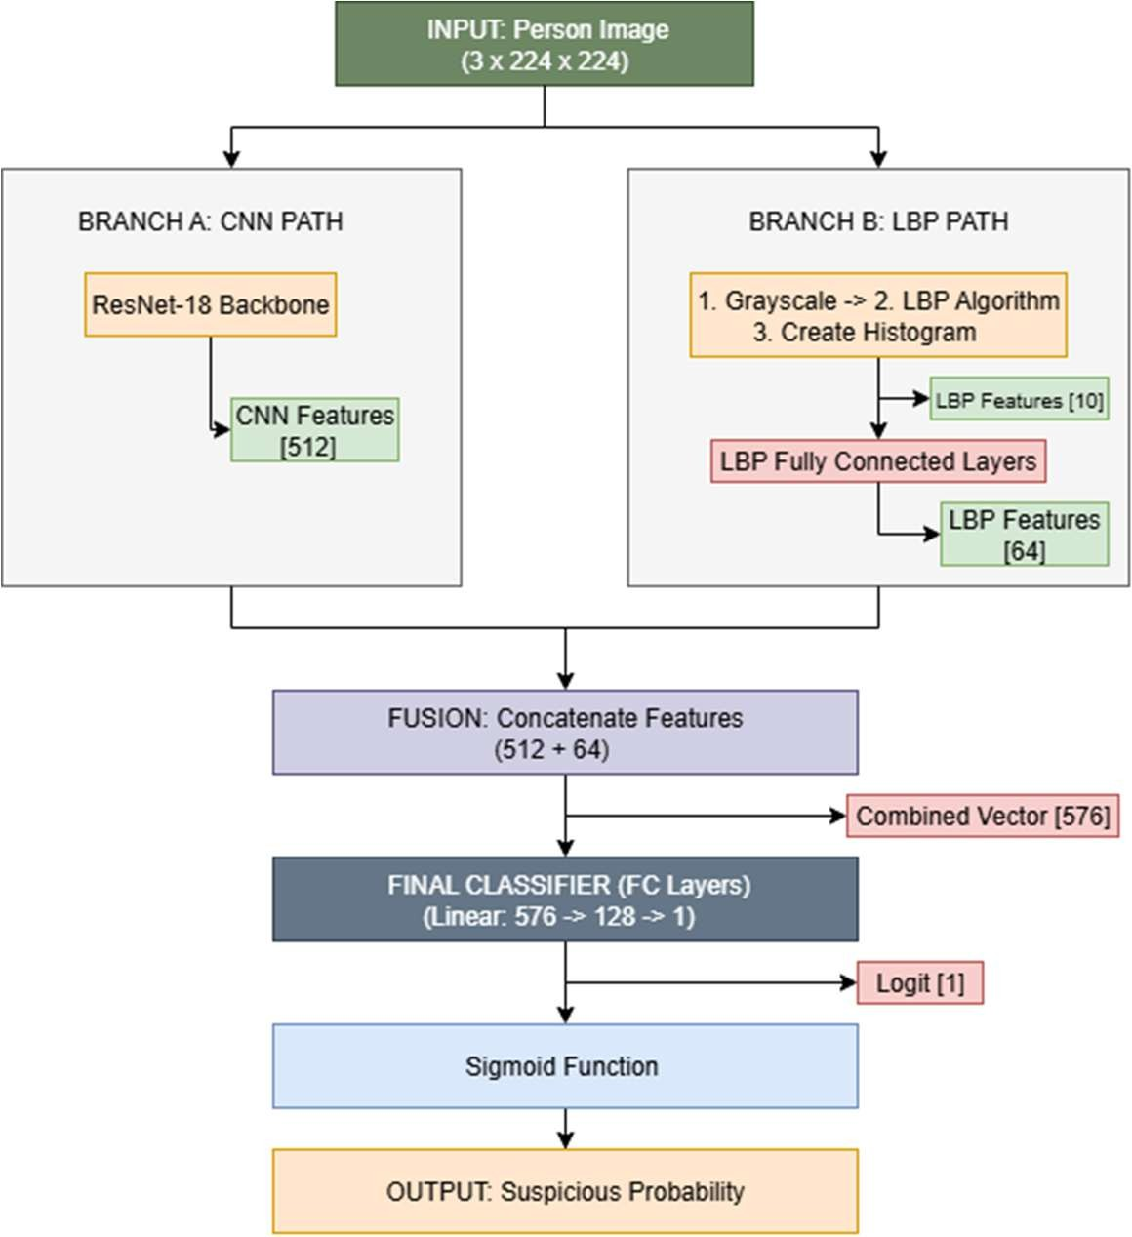
Figure 3.2: YOLO+LBPH+CNN

The extraction of features in the LBPH is:
The input image is transformed into grayscale colorspace and reduced in size to 128×128 pixel size.
Then it traverses all the pixels in the grayscale image. For each inner pixel (xc,yc) whose intensity is gc, it examines a circular neighborhood containing a fixed number P whose intensity is gp.
Binary code is thus formed by a comparison between a center pixel intensity and its neighbors. 1 is assigned if neighbor intensity is at least as great as or greater than a center one, otherwise 0. That is described by a function s(x) in (vi):
𝑠(𝑥) = 𝑖𝑓 𝑥 ≥ 0 𝑒𝑙𝑠𝑒 {¹ q (vi)
0
𝑐 = 𝑃(𝑝𝑒𝑟𝑠𝑜𝑛 𝑜𝑟 𝑔𝑢𝑛) (vii)
These are binary values which are grouped in a P-bit binary number and are converted into a decimal number. These LBP values for each pixel are then obtained as per the following Equation (vii):

𝐿𝐵𝑃(𝑥_{c}, 𝑦_{c}) = ∑^{P–1} 𝑠(𝑔_{p} − 𝑔_{c}). 2^{p}
P=0
(viii)

𝐻_{LBP}(𝑘) = 𝑐𝑜𝑢𝑛𝑡 𝑜𝑓 𝑝𝑖𝑥𝑒𝑙𝑠 𝑤ℎ𝑒𝑟𝑒 𝐿𝐵𝑃 = 𝑘 (ix)

𝑦 = 𝜎(𝑊fc. 𝐻LBP + 𝑏fc) (x)
After this LBP value for every pixel in an image is calculated, a histogram (HLBP) is constructed over all such values. Such a histogram is a distribution representation within an image for micro-textures and is a concise feature vector with high descriptiveness. This feature extraction by LBPH is a strong, engineered set of features supplemented by what is learned by the CNN. A CNN excels at perceiving the semantic content of the image (the "what"), whereas what is learned by the LBPH is a capture of the surface texture (the "how") in an illumination-invariant form. By combining these two feature vectors—they are usually combined by concatenating the flattened output of the penultimate layer in the CNN with the LBPH histogram—the final classifier is given a considerably richer, more robust representation of input.

PROPOSED METHODOLOGY
For our methodologies, we are going to use two datasets named CrowdHuman and OpenV6 Images Datasets. The CrowdHuman Dataset is a large-scale pedestrian which is used to detect humans from crowded areas in different brightness, occlusions, and various human poses. The OpenV6 Images Dataset is for detecting the weapons and guns alongside people and allowing our system to learn and detect the occurrence of humans. Together these datasets offer mix dense of crowd scenarios, action recognition and object detection contexts necessary for developing and evaluating for hybrid intruders' detection models.
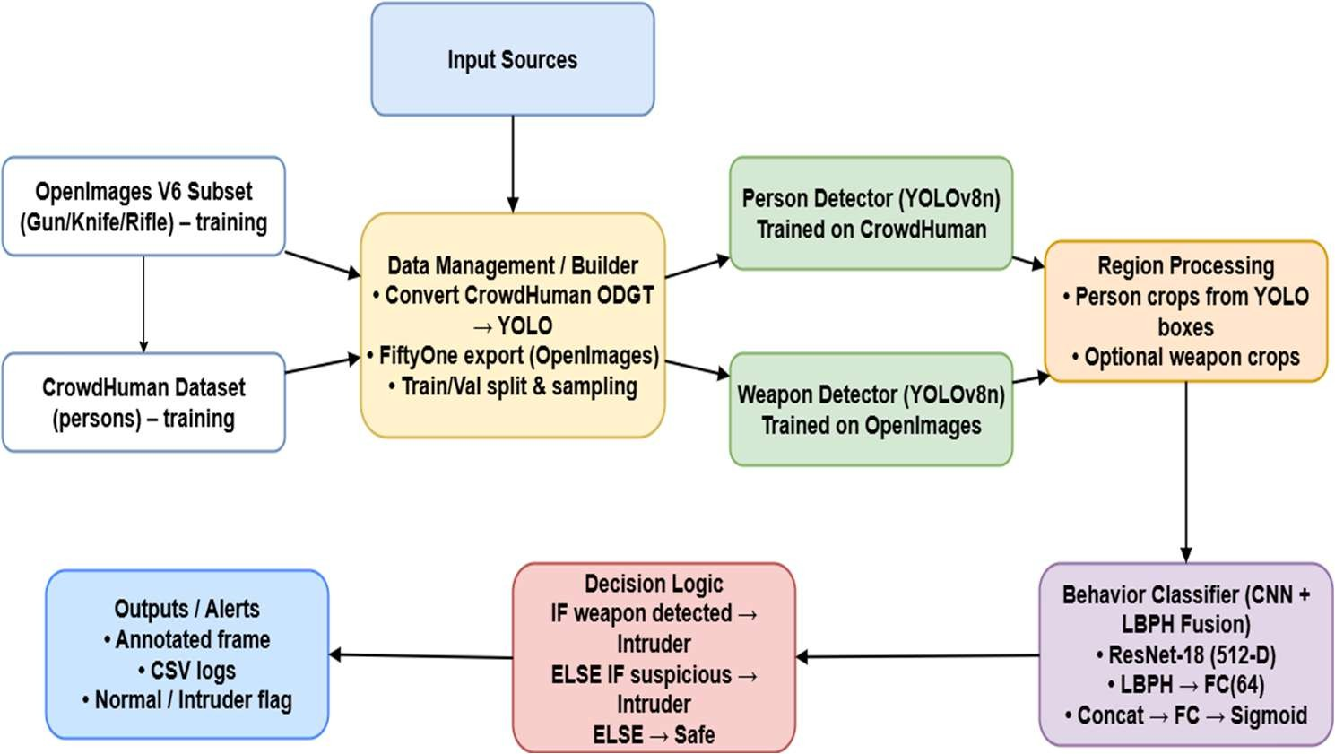
Figure 3.3:Finalized Methodology

Chapter 4 RESULT & DISCUSSION
This chapter provides a deeper analysis of the experimental results presented in Chapter 4. It moves beyond the reporting of metrics to interpret their significance, focusing on why the proposed YOLO+CNN+LBPH model was ultimately selected over alternatives that showed higher training accuracy. The discussion will dissect the role of the hybrid architecture in mitigating overfitting and analyze the qualitative results to understand the system's practical performance.
We quantify performance using standard metrics. Let TP = true positives (unauthorized faces correctly detected), TN = true negatives (authorized correctly passed), FP = false positives (authorized flagged as intruder), FN = false negatives (intruders missed). Then:

Accuracy= TP+TN
TP+TN+FP+FN

PRECISION= TP
TP+FP

RECALL= TP
TP+FN
F1-SCORE=2× PRECISION×RECALL
PRECISION+RECALL

(xi)

(xii)

(xiii)
(xiv)

ROC-AUC: area under the Receiver Operating Characteristic curve, summarizing trade- off over thresholds.

FALSE ALARM RATE= FP
FP+TN

IMAGES PERSON DETECT AND WEAPON
(xv)

Since there were strict computational restrictions involved, training datasets were compressed into 25% of their actual size. YAML configuration files were made for every dataset for proper handling of training in order to specify paths, class names, and other essential parameters for training in YOLOv8.
The technical implementation of the models was carried out using the PyTorch deep learning framework. The person detector (YOLOv8n) was trained on the CrowdHuman dataset for 36 epochs, while the weapon detector (YOLOv8n) was trained on the OpenImages V6 subset for 50 epochs. These epoch counts were determined empirically to achieve convergence without significant overfitting on their respective validation sets. The behavior classifier, built upon a pre-trained ResNet18 backbone, was trained using a batch

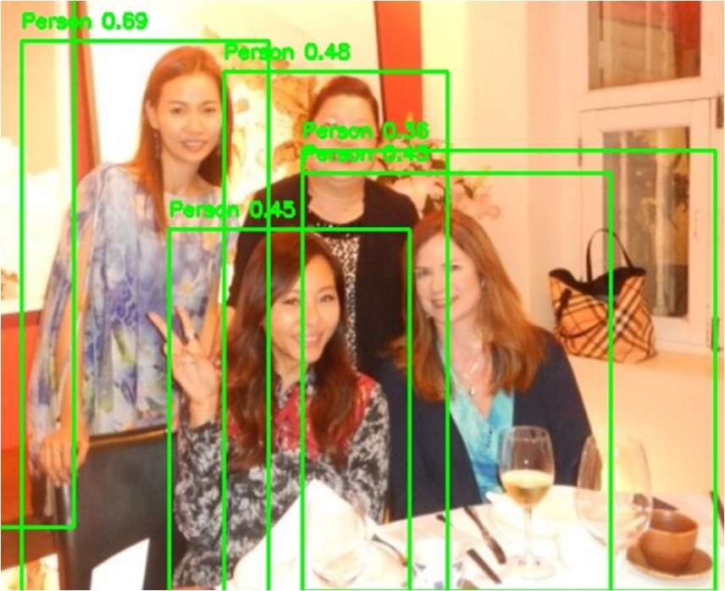
size of 64. The LBPH branch was integrated with the CNN's fully connected layers, which utilized ReLU activation functions and dropout for regularization.
Figure 4.1:CrowdHuman
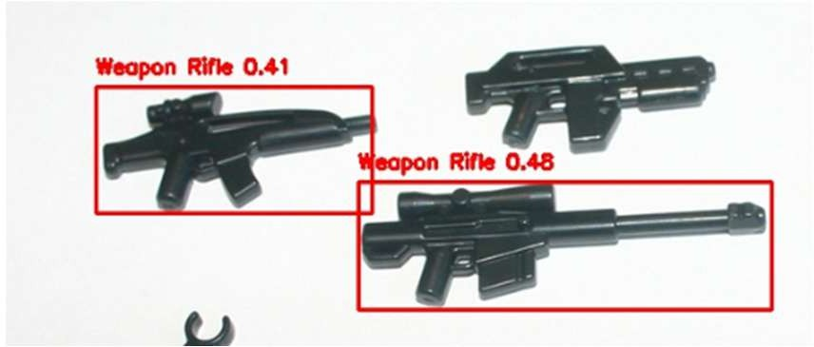
Figure 4.2:OpenV6Images

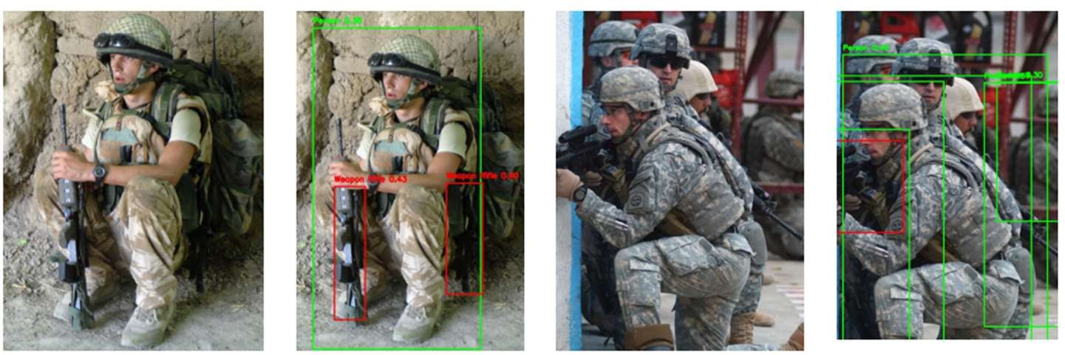
Through the above figures defined above , we can say that the model which we are trying to make hybrid is being properly done we have compared using different models with, but while running with epochs we were not able to identify at first what are the results we want are we getting correctly or not as the model was also overfitting in nature but then we did two things as datasets was too heavy but we tried to generate YAML for each dataset. As computational constraints were there we reduced the sampling to 25% while meeting enviroment limits. Crowdhuman and OpenImages one is being trained with 36 epochs and another one is being is trained with 50 epochs for the qualitative tests to show stable person boxes in validation samples and for Gun/Knife/Rifle reliabiliy in held out images.
Fig 4.3: Results with the Combining two dataset

At the time of behaviour classifier we have used CNN+LBPH fusion where we have tried to work with the help of backbone based on Pytorch model of ResNet18 where in the LBPH branch we have fully connected layers with a batch size of 64 and ReLU plus the droput part from the CNN. We also had worked upon YOLO+CNN so we finalized this YOLO+LBPH+CNN as we had the other reason also that validation loss was not increasing in the nature and we were getting the accuracy as 70% but in this case the validation loss was the least , reason behind is it took less amount of time as compared to other models and likewise whatever the output we wanted in our case while testing it was around 0.7631 as compared to different models where there testing accuracy was around 55.59%.
In our results we also calculated support in which we tried to identify how frequent persons with weapons or without weapons are being included so that we can see who is having a normal behaviour or suspicious behaviour.

YOLO+CNN
The qualitative detection results of the two YOLOv8n detectors were assessed using validation samples. Both models exhibited strong and stable detection behavior. The detector for people correctly localized individuals even in changed lighting conditions and pose positions, for example in Figure 7. Likewise, the detector for weapons consistently detected weapons in held-out scenes by enclosing the objects of interest in tight bounding boxes, for instance in Figure 8. These results prove that the first detection step within the pipeline works correctly and supplies steady input for the last behavior classification module.
TABLE 4.1: Classification Report of YOLO+CNN
 | Precision | recall | f1-score | support
Normal | 0.69 | 0.66 | 0.67 | 811
Weapon | 0.67 | 0.7 | 0.68 | 810
accuracy |  |  | 0.68 | 1621
macro avg | 0.68 | 0.68 | 0.68 | 1621
weighted avg | 0.68 | 0.68 | 0.68 | 1621

YOLO+CNN+LBPH
The last proposed model, which combined attributes of the CNN as well as the LBPH descriptor, had the best results. Another key result in the experimental phase was the compromise between training accuracy and model generalizability.
As a direct comparison, the proposed model YOLO+CNN+LBPH, which attained a more humble training accuracy of approximately 70%, had the lowest and most consistent validation loss out of all the configurations tried. This reflects its best capability to generalize from training examples to unseen examples. The test set final accuracy for this model was 0.7631, which while numerically lower than training accuracies for overfit models, is a much more robust and realistic indicator of this model's actual performance. Based upon its strong capability for generalization, its efficiency, and its consistent test set performance, it proved itself to be the best and most robust solution for the specified task. These results, including people classifications as 'Normal' or 'Suspicious', are shown in Figures 6 and 9.
TABLE 4.2: Classification Report of YOLO+LBPH+CNN
 | precision | recall | f1-score | support
Normal | 0.71 | 0.68 | 0.69 | 600
Weapon/Suspicious | 0.69 | 0.72 | 0.7 | 600
accuracy |  |  | 0.7 | 1200
macro avg | 0.7 | 0.7 | 0.7 | 1200
weighted avg | 0.7 | 0.7 | 0.7 | 1200

Investigation on the Performance of the Hybrid Model and Overfitting Mitigation
The project's most striking outcome is not achieving a certain level of accuracy but an experimental proof of concept for design decisions leading towards a more robust and generalizable model. Overfitting was a dominant issue throughout the experimentation phase, a common failure mode in deep learning in which a model learns a training set too accurately, including noise and extraneous correlations within it, and is thus unable to perform on unseen test data. The selection of the YOLO+CNN+LBPH model, even with its lower training accuracy of 70%, was a scientifically rigorous decision driven by its superior performance on the validation set. The key metric in this decision was the

validation loss, which remained low and stable for the proposed model, while it increased for the others. This indicates that the hybrid model was successfully learning features that generalized beyond the training data. The rationale for this improved generalization lies in the concept of feature fusion. The CNN component is adept at learning high-level, semantic features related to shape, posture, and context. However, it can be sensitive to surface-level variations like lighting, shadows, and texture that may not be relevant to the classification task. By forcing the model to also consider features from the LBPH descriptor, which are inherently robust to illumination changes, the system becomes less reliant on these potentially misleading cues. The LBPH component acts as a form of regularization, anchoring the model's decision-making process in more fundamental textural patterns. This prevents the classifier from overfitting to incidental lighting conditions or background artifacts present in the training images.
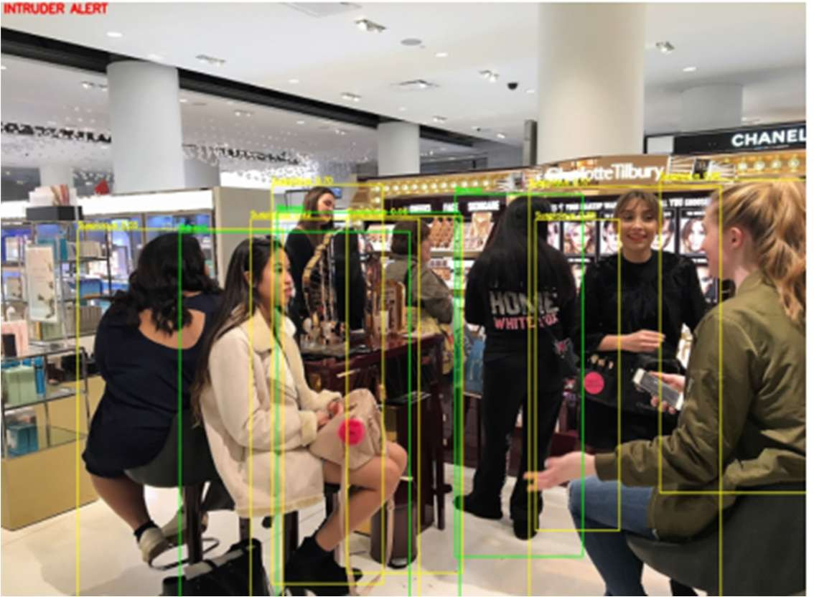
Here is a simple comparison table between the model architectures tested above with an indication of a major trade-off between training set performance versus generalization.
Fig 4.4: Normal vs Suspicious in the image

Detection Scenario Interpretation and System Performance
Exploring the qualitative results of the system offers more information about its real- world performance. As can be observed in Figure 6, the system shows its capability for taking in a scene and making a judgment according to the integrated feature set. Under the 'Normal' condition, the system accurately detects a person in a neutral posture without threatening items and gives an appropriate label. Under the 'Suspicious' condition, the system raises an alarm for an individual, probably because there is a combination of features

learned in CNN (e.g., a certain posture or possession of a weapon-like object) in combination with textural information in LBPH.
The strength of the hybrid approach is its ability to handle ambiguity. For instance, a person holding a dark, metallic object could be holding a phone or a weapon. A purely CNN- based model might over-rely on color and shape cues learned from the training data. However, the LBPH component provides an additional layer of information about the object's surface texture. The fusion of these features allows the model to make a more informed decision, potentially reducing false positives (e.g., misidentifying a benign object as a threat) that could arise from relying on a single feature modality.
A basic behaviour classification model based solely on YOLO and a CNN was first tested. Such a model inputted the YOLO detector's cropped image of a person directly into the classifier based on ResNet18. Although such a method is a typical deep learning pipeline, there were some initial experiment results which showed it overfitted. The model would obtain a high accuracy on the training set but less reliably on the validation set, which meant it was picking up superficial features rather than meaningful features which it didn't generalize as well when it came to encountering unseen information. Such a result led to trying a more resilient, hybrid model.
The decision to finalize this model was based on its robust generalization capabilities, its efficiency, and its consistent performance on the test set, proving it to be the most effective and reliable solution for the defined task. The results, including the classification of individuals as 'Normal' or 'Suspicious', are visualized in Figures 6.

COMPARE METHODOLOGY & SHOW RESULT
The Light-Weight RetinaNet by Li & Ren and your Intruder Detection System are also working for optimizing object detection while focusing on other areas. Li & Ren focused on the minimization of FLOPs for enabling RetinaNet for use in more mobile and embedded applications while preserving accuracy and attaining approximately 34–35.6% mAP on COCO while reducing FLOPs by up to 1.8× at less than a 1% loss of accuracy. In contrast, your project addresses security and surveillance by intruder detection using a two- stage pipeline: YOLOv8 models for efficient human and weapon detection (trained on CrowdHuman and OpenImages) and a CNN+LBPH hybrid classifier for analysis of suspicious behavior, increasing accuracy from ~68% (CNN-only) to ~70% (hybrid) with AUC ~0.76. Though RetinaNet work focuses on computational trade-offs for cross-purpose

detection, your system applies detection models under GPU restrictions (employing ¼th data for model training) for practical CCTV deployment. Herein, the prime contrast is one of scope: RetinaNet pushes the efficient object detection research agenda, while your work applies lightweight detection and hybrid modeling for real-world use cases in surveillance, focusing more on real-time alerting and robustness rather than purely benchmark-motivated accuracy.

CHAPTER 5 CONCLUSION & FUTURE WORK

CONCLUSION
This project effectively designed, implemented, and tested a hybrid deep learning pipeline for real-time intrusion detection. The system effectively combines YOLOv8's high-speed object detection capacity with a new and resilient behavior classification module which blends features between a Convolutional Neural Network and Local Binary Pattern Histograms. The main contribution of this research is creating a model which exhibits superior generalizability while resisting severe overfitting which befell competing architectures. The final YOLO+CNN+LBPH model offers a robust, resource-lean, and consistent baseline for object detection combined with fine-grained behavior analysis for flagging suspicious individuals in video surveillance. The study verifies a hybrid method which blends learned semantic features with hand-designed, illumination-robust texture features can produce a more resilient and practical real-world security solution than a solely deep learning method.

Limitation and Future Work
While the proposed system is a strong proof-of-concept, it is marred by several shortcomings which open up obvious paths for further research and productization. Currently, the system analyzes each video frame independently without any recourse for maintaining any temporal contextualization of action. Secondly, correlating a detected weapon with an individual carrying it is an implicit rather than an explicit correlation.
To overcome such drawbacks and enhance the system further, there is a plan for developing the following regions in the coming future: IoU-based Weapon-to-Person Mapping: A significant enhancement would be to implement an explicit association between detected weapons and persons. This can be achieved by calculating the Intersection over Union (IoU) of the bounding boxes for detected weapons and persons. If the IoU between a weapon's box and a person's box exceeds a certain threshold, the weapon can be definitively assigned to that individual, creating a more precise and actionable alert. Temporal Modeling for Behavior Analysis: To shift from static image analysis towards actual human activity recognition, temporal modeling approaches need to come into play. LSTM

networks or Transformers are some examples of such approaches in architectures which might come into use following the feature extraction step. These are models which can handle sequences of data; thus, it is possible for a system to take a sequence of frames for processing so it can recognize actions and behaviors in a sequence over time. That would allow for detection of intricate suspicious activity such as loitering, fighting, or leaving an unattended object. Dataset Increase and Diversification: Any deep learning system's effectiveness is directly constrained by training data quality and diversity. A direction for further research is widening the datasets such that they contain a greater range of environments, lighting conditions, weapons (even concealed weapons), and less restrictive human pose and behaviors. That would make the model even more robust while further decreasing false positives and false negative rates. Reduction of False Alarms: To make the system more practical for real-world applications, mechanisms for reducing false alarms should be considered. That might involve using a multi-frame validation logic in which a potential threat should be identified consistently in multiple consecutive frames before an alarm should be raised. Further refinement of the classification threshold based on an analysis of a ROC curve should also be able to identify an optimum balance between sensitivity and specificity for a particular operating environment. By investigating such channels, what amounts to an efficient crime reporting system can further be refined as a still more effective tool for crime prevention and public safety.

References

- N. C. Rodelas and M. A. Ballera, “Intruder detection and recognition using different image processing techniques for a proactive surveillance,” Indonesian Journal of Electrical Engineering and Computer Science, vol. 24, no. 2, pp. 843–852, Nov. 2021, doi: 10.11591/ijeecs.v24.i2.pp843-852.
- Z. Wang, F. A. Ghaleb, A. Zainal, M. M. Siraj, and X. Lu, “An efficient intrusion detection model based on convolutional spiking neural network,” Sci Rep, vol. 14, no. 1, Dec. 2024, doi: 10.1038/s41598-024-57691-x.
- J. Esmaily, R. Moradinezhad, and J. Ghasemi, “Intrusion detection system based on Multi-Layer Perceptron Neural Networks and Decision Tree,” in 2015 7th Conference on Information and Knowledge Technology, IKT 2015, Institute of Electrical and Electronics Engineers Inc., Oct. 2015. doi: 10.1109/IKT.2015.7288736.
- S. Shao et al., “CrowdHuman: A Benchmark for Detecting Human in a Crowd,”
Apr. 2018, [Online]. Available: http://arxiv.org/abs/1805.00123
- M. M. Ahsan, Y. Li, J. Zhang, M. T. Ahad, and K. D. Gupta, “Evaluating the Performance of Eigenface, Fisherface, and Local Binary Pattern Histogram-Based Facial Recognition Methods under Various Weather Conditions,” Technologies (Basel), vol. 9, no. 2, Jun. 2021, doi: 10.3390/technologies9020031.
- D. Bhamare et al., “Smart Intruder Detection System Using Machine Learning,” Int.
J. Innov. Res. Sci. Eng. Technol., vol. 11, no. 5, May 2022.
- R. Raghupathy, M. Akash, C. Dineshkumar, N. Hariharan, and R. Jayasurya, “Real Time Security System using YOLO Technology,” Int. J. Innov. Technol. Explor. Eng., vol. 11, no. 8, Jul. 2022.
- T. Sanjay and W. D. Priya, “Efficient system for criminal face detection… using LBPH in comparison with CNN,” J. Pharm. Negative Results, vol. 13, no. S4, 2022.
- S. Pavithra and B. Muruganantham, “An analysis of burglary detection based on YOLO framework,” J. Comput. Sci., vol. 19, no. 11, pp. 1345–1358, 2023.
- B. Bhuckory and S. Pudaruth, “A Multimodal IoT-Based Home Intrusion Detection System,” Int. J. Comput. Theory Eng., vol. 15, no. 3, Aug. 2023.





































INTRUSION DETECTION SYSTEM
Aumansh Vijayendra Gupta, Sachin Kumar Aman, Radhika Pithva, Dr. Anjali Diwan¹ ¹Computer Engineering Department, Marwadi University, Rajkot

Abstract—The growing concerns of unauthorized access in secure organizations is still going on and there is a need for an intelligent system that can detect intruders in real time. This project proposes a hybrid system for detection of intrusions combining speed and efficiency of Convolution neural network and Linear Binary Pattern Histogram for the classification of weapons and crowd by using the CrowdHuman and Open V6 Images Dataset so that for once the system will determine from the image whether the image of that person in it is having a suspicious or is a normal person so that our model will be taking care to make decisions accordingly whether the intruder is having weapon or not. System is being trained and evaluated using CrowdHuman to detect humans and OpenV6 Gun dataset to handle scenarios involving potential threats. The results which are the best is YOLO+LBPH+CNN with an accuracy of 70%. We compared it with YOLO+CNN but we got 68%. So the final method which we had proposed is YOLO+LBPH+CNN. It allows robust classification even in challenging scenarios such as lighting, exposure and crowded scenes. Results are accurate than the older systems which are being proposed by other authors.
Keywords—CrowdHuman, OpenV6 images, YOLO, CNN, LBPH, object detection, computer vision, intruder detection system
  - Introduction
In a time when security threats are on a constant rise, there is a greater need for sophisticated surveillance systems today than ever before. Conventional security infrastructures, commonly based on passive Closed-Circuit Television (CCTV) [1] solutions, are no longer effective in inhibiting unlawful access and violent outbreaks insecured locations like banks, business offices, and public buildings. These conventional solutions are usually in the form of post-incident recording tools with minimal real-time threat detection and active intervention capability. Limitations in human surveillance such as fatigue, distraction, and information overflow by virtue of competing multiple camera feeds make a shift towards smart, automatic surveillance solutions a requirement.[1]
This system design is an intricate engineering solution for an inherently intricate challenge. Deploying a computationally burdensome classifier on a complete high- resolution video frame would not be feasible for real-time operation. However, the YOLOv8 [2] detector operates as a smart "attention mechanism." It quickly surveys the frame and winnows the tremendous amount of visual information down to just those most salient regions of interest—the detected persons' bounding boxes. Doing so makes it possible to use only where needed a more powerful and resource-hungry CNN+LBPH classifier while still allowing a system fast enough for real-time use yet accurate enough for effective threat assessment.[12]
The main objectives for this project are thus defined as:
To implement and execute a modular pipeline for people and possible weapons detection from live video streams based on the YOLOv8 algorithm.
To develop and train a hybrid classifier model which is a combination of hand-crafted texture features in LBPH as well as deep features in a CNN for effective classification of detected people as 'Authorized/Normal' or 'Intruder/Suspicious'.
To perform a comparison study between proposed hybrid model and other alternative architectures based on investigating model generalization in order to curb overfitting common issue.[4]
To generate a concluding system which achieves a balance between high accuracy and computational effectiveness while ensuring its applicability for real applications in realistic security scenarios.
  - Literature Review
Through so many papers, we studied the intrusion detection using PCA which is done by Rodelas N et al. [1] and we can say that in the paper itself whatever they have used the dataset and made up to 93% accuracy, but they do not have a working in real time dataset.
The paper of Wang Z. et al. [2] in which they proposed Convolutional SNN, but the problem is that CNN outperforms their hybrid model, and the experiment are being conducted only on public datasets and no more evaluation of diverse dataset and there was a hardware dependency, so it is unclear how model performs on actual edge devices.
In another paper of Esmaily J. et al.Through so many papers, we studied the intrusion detection using PCA which is done by Rodelas N et al. [5]and we can say that in the paper itself whatever they have used the dataset and made up to 93% accuracy, but they do not have a working in real time dataset.
The paper of Wang Z. et al. [6] in which they proposed Convolutional SNN, but the problem is that CNN outperforms their hybrid model, and the experiment are being conducted only on public datasets and no more evaluation of diverse dataset and there was a hardware dependency, so it is unclear how model performs on actual edge devices.
In another paper of Esmaily J. et al. [7] the methods were of the Random Forest Decision Tree and the simple multi- layer perceptron method on KD Cup 99 Dataset, but the limitation is they have an offline system where they designed and tested, that means it does not process live traffic, plus no demonstration of real time capability.
In the paper of Talib M et al. [8] where they have used deep learning to detect multi weapons and they have used their self-curated dataset and used YOLOv7 (You Look Only Once) & CNN (Convolution Neural Network) , but the limitations were the lack of focus on weapon types, no in- depth analysis of False Positives and Negatives.
The next paper which is about Shao S et al. [9] A benchmark for detecting human in crowd where they have used Faster RCNN and FPN which serves the main part of detecting visible body but can introduce domain bias, no fined grained identity labels and occlusions remain extremely challenging.

Some recent publications explored real-time intrusion detection by means of deep learning. As an illustration, Bhamare et al. (2022) presented a "Smart Intruder Detection System" which is fitted with a CNN for threat detection and intruder detection as well as YOLO (You Only Look Once) for guns detection [10].
Their computer-vision pipeline (OpenCV + CNN + YOLO) was very accurate for detection of weapons and intruders in CCTV footage. Moreover, Pavithra et al. (2023) employ a pre-trained model of YOLO (which is trained on MS-COCO) for real-time detection of theft by resizing and normalizing frames for increased real-time effectivenessthese. These YOLO-type solutions demonstrate how you can very rapidly identify objects (e.g. people, guns) in pictures in order to support rapid intrusion detection. To perform on high- definition video in real-time, though, you might need robust edge hardware.
Another component is face recognition for validating whether a detected face is allowed. Several such systems use the Local Binary Pattern Histogram (LBPH) method for this. Sanjay and Deva Priya in a comparison between CNN and LBPH for crime face recognition concluded that LBPH was slightly more precise.
They argue that computational efficiency and lighting robustness of LBPH render it suitable for surveillance. Raghupathy et al. demonstrate in action: in their smart security camera system augmented by YOLO, they "employed the Local Binary Pattern Algorithm (LBPH) detection and identification [of faces] for distinguishing between unauthorized people and legitimate users [11]. In fact, their paper describes cutting recognition time considerably while tolerating only minimal accuracy loss when applying LBPH[12].
  - Reserch Methodology
The system is having the architecture which is based on a synergistic pipeline consisting of rapid object detection combined with strong, multi-modal feature extraction for proper behavior classification. This option was made in order to develop a system both effective in its classification capabilities as well as computationally feasible for real-time surveillance use. Central to its methodology is its YOLO+CNN+LBPH framework. This architecture uses YOLOv8 for its best-of-class speed and accuracy in object detection for people and weapons. Once detected, a hybrid feature fusion method is used for classification. This consists of a combination of a CNN's hierarchical, abstract visual features learned for a subject with Local Binary Pattern Histograms (LBPH)'s fine-grained, illumination-invariant texture information. Another hybrid method in a YOLO framework involving a combination or integration for a deep network with an LBP layer within a detection framework has been shown in other detection tasks involving greater difficulty to succeed as a strong precedent for this methodological selection.
- Dataset Description
CrowdHuman Dataset: It is a large-scale test dataset exclusively for pedestrian detection in extremely crowded scenes. It includes detailed annotations for full bodies, occluded/visible body parts, as well as head-oriented bounding boxes. Its contribution is essential in training a
person detector robustly even in real-world environments with heavy occlusion and diverse human poses.
OpenImages V6 Dataset: It is a large, variform dataset which comprises millions of images annotated with thousands of object classes. There is a subset of this dataset which is specifically annotated with weapons such as guns and knives. It was employed for training a model for detection of weapons. Due to its sheer richness in object appearances, background variations, and lighting conditions, there is a need for this dataset for creating a generalizable detector for weapons.
- YOLO
The first and most essential phase in the system pipeline is object detection and localization within the video stream. For this purpose, the YOLOv8 model was chosen. As the most recent successor in the You Only Look Once lineages, YOLOv8 achieves a remarkable balance between ultrafast speed and detection performance and is thus a prime candidate for real-time detection for weapons as well as people tracking.
YOLOv8 architecture is made up of three components: Backbone: A CNN at a deeper level which learns a rich hierarchy of features at multiple scales in the input image.
CERVICAL: A sequence of layers like a Feature Pyramid Network (FPN), which collect and pool features at multiple stages in a backbone. It allows for efficient object detection at a range of scales.
Head: Last element in the network which makes prediction based on combined features and returns objectness score, class probabilities for detected objects, and coordinates for bounding box.
Once an object is detected, the model outputs its bounding box coordinates, defined as b=(x,y,w,h), where (x,y) are the center coordinates and (w,h) are the width and height, respectively.
  - Use either SI (MKS) or CGS as primary units. (SI units are encouraged.) English units may be used as secondary units (in parentheses). An exception would be the use of English units as identifiers in trade, such as “3.5-inch disk drive”.
  - Avoid combining SI and CGS units, such as current in amperes and magnetic field in oersteds. This often leads to confusion because equations do not balance dimensionally. If you must use mixed units, clearly state the units for each quantity that you use in an equation.
  - Do not mix complete spellings and abbreviations of units: “Wb/m2” or “webers per square meter”, not “webers/m2”. Spell out units when they appear in text: “. . . a few henries”, not “. . . a few H”.
  - Use a zero before decimal points: “0.25”, not “.25”. Use “cm3”, not “cc”. (bullet list)
- CNN
After a successful detection of an individual by YOLOv8, a region specified by the bounding box is trimmed from the original frame. This trimmed image which separates an individual of interest is further sent for behavior classification. The main constituent of this is a Convolutional Neural Network (CNN), a type of deep neural network expressly created for processing and visual imagery analysis.

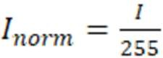
Preprocessing is first applied to the person crop image by resizing it to a fixed size of 224×224 pixel and scaling up the pixel intensity values between 0 to 1. This is accomplished by dividing pixel intensity value I by 255, as in Equation (i):

(i)
Normalized image is then fed into CNN. We take a ResNet18 model as our backbone for our project.
Convolutional Layers: These layers apply a series of learnable filters (kernels) on the input image, producing feature maps which recognize low level features like edges and texture in early layers, and high level abstract features like shapes and object parts in later layers. We can define its operation by Equation (ii), where W is filter weight, b is bias, and ReLU is activation function:
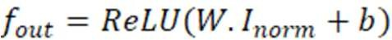
(ii)
Downsampling Pooling Layers: These layers reduce the size of feature maps by downsampling them. This step minimizes parameters as well as computational intensity so that it can make a network efficient and prevent overfitting.
Fully Connected Layers: Once certain layers of convolution and pooling are traversed, their respective feature maps are transformed into a one-dimensional vector. This is passed through one or multiple fully connected layers which perform the final classification job. These layers learn nonlinear combinations within the high-level features learned by the convolution layers. Output of a fully connected layer is specified by Equation (iii):
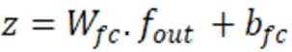
(iii)
The last layer employs a softmax activation function so it outputs a probability distribution over the potential classes ('Normal' or 'Suspicious'), which is given in Equation (iv):
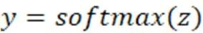
(iv)
For training, a model is best when it minimizes a loss function which is typically binary cross-entropy loss in a binary issue, as outlined in Equation (v), in which y is the true label:
(v)
The CNN's job in this pipeline is obtaining high-level semantic signals in people's behavior according to their appearances, such as their posture, their gesture, or if they are holding an object.
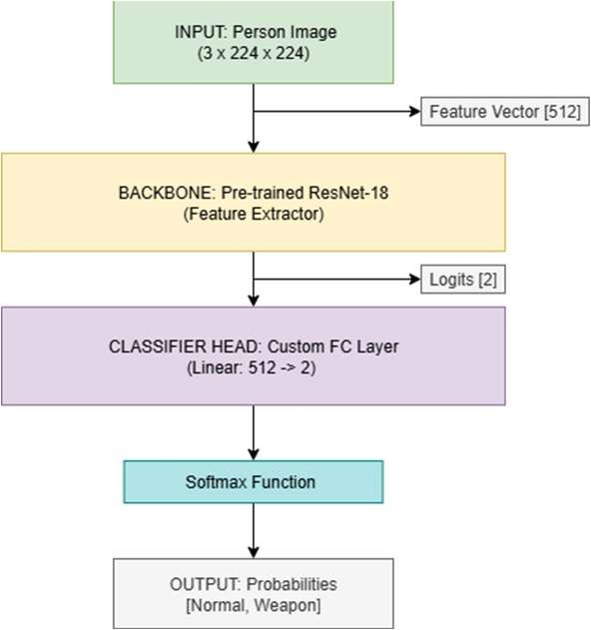
Fig. 1. CNN architecture
- LBPH
To improve the model's robustness even further, specifically in coping with lighting variation, a parallel branch for extracting features based on the Local Binary Pattern Histograms (LBPH) algorithm is introduced. LBPH is a strong and computationally friendly texture descriptor which is found to perform remarkably in numerous applications in computer vision such as in facial recognition as well as in security applications. Its main benefit is its monotonic grayscale invariance which is a typical issue in practical surveillance applications.
The extraction of features in the LBPH is:
The input image is transformed into grayscale colorspace and reduced in size to 128×128 pixel size.
Then it traverses all the pixels in the grayscale image. For each inner pixel (xc,yc) whose intensity is gc, it examines a circular neighborhood containing a fixed number P whose intensity is gp.
Binary code is thus formed by a comparison between a center pixel intensity and its neighbors. 1 is assigned if neighbor intensity is at least as great as or greater than a center one, otherwise 0. That is described by a function s(x) in (vi):
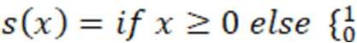 q (vi)
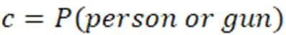
(vii)
These are binary values which are grouped in a P-bit binary number and are converted into a decimal number. These LBP values for each pixel are then obtained as per the following Equation (vii):
(viii)
(ix)
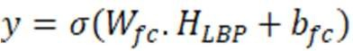
(x)
After this LBP value for every pixel in an image is calculated, a histogram (HLBP) is constructed over all such values. Such a histogram is a distribution representation within an image for micro-textures and is a concise feature vector with high descriptiveness.. A CNN excels at perceiving the semantic content of the image (the "what"), whereas what is learned by the LBPH is a capture of the surface texture (the "how") in an illumination-invariant form. By combining these two feature vectors—they are usually combined by concatenating the flattened output of the penultimate layer in the CNN with the LBPH histogram—the final classifier is given a considerably richer, more robust representation of input. The combined feature vector is input to a final fully connected layer for making the final classification determination.

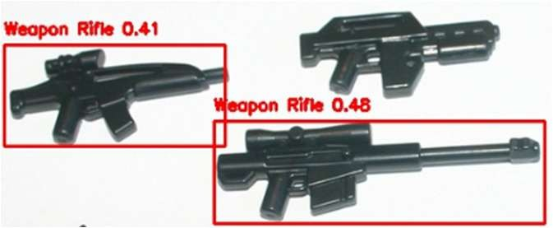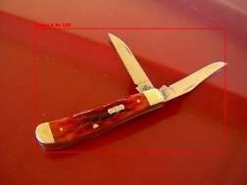

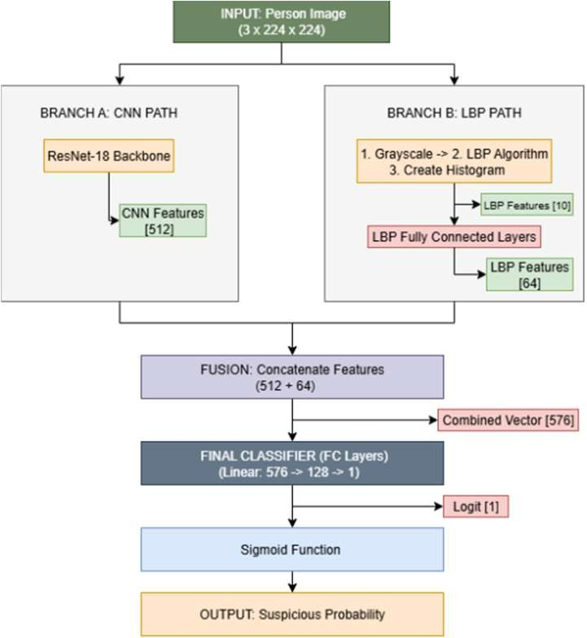
Fig. 2. LBPH architecture

  - Proposed Framework
For our methodologies, we are going to use two datasets named CrowdHuman and OpenV6 Images Datasets. The CrowdHuman Dataset is a large-scale pedestrian which is used to detect humans from crowded areas in different brightness, occlusions, and various human poses. The OpenV6 Images Dataset is for detecting the weapons and guns alongside people and allowing our system to learn and detect the occurrence of humans. Together these datasets offer mix dense of crowd scenarios, action recognition and object detection contexts necessary for developing and evaluating for hybrid intruders' detection models.
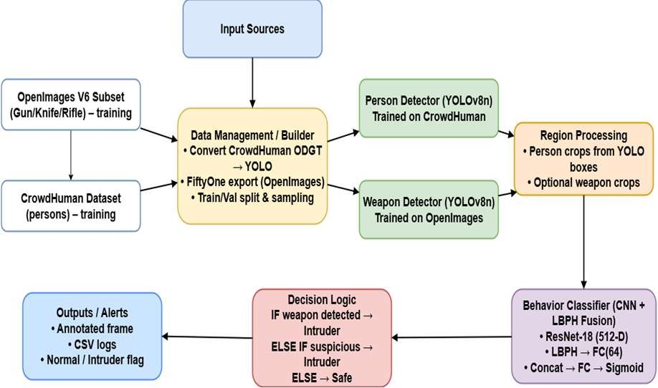
Fig. 3. Proposed Framework

Since there were strict computational restrictions involved, training datasets were compressed into 25% of their actual size. YAML configuration files were made for every dataset for proper handling of training in order to specify paths, class names, and other essential parameters for training in YOLOv8.
Fig. 4. Person and Weapon Detection

The technical implementation of the models was carried out using the PyTorch deep learning framework. The person detector (YOLOv8n) was trained on the CrowdHuman dataset for 36 epochs, while the weapon detector (YOLOv8n) was trained on the OpenImages V6 subset for 50 epochs. These epoch counts were determined empirically to achieve convergence without significant overfitting on their respective validation sets. The behavior classifier, built upon a pre- trained ResNet18 backbone, was trained using a batch size of
64. The LBPH branch was integrated with the CNN's fully connected layers, which utilized ReLU activation functions and dropout for regularization.
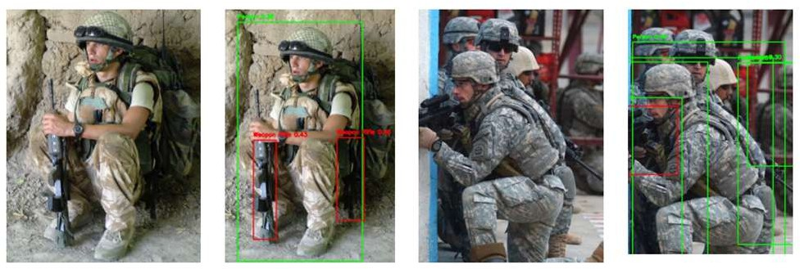

Fig. 5. After converting into YOLO format final results

At the time of behaviour classifier we have used CNN+LBPH fusion where we have tried to work with the help of backbone based on Pytorch model of ResNet18 where in the LBPH branch we have fully connected layers with a batch size of 64 and ReLU plus the droput part from the CNN. We had worked upon YOLO+CNN so we finalized this YOLO+LBPH+CNN as we had the other reason also that validation loss was not increasing in the nature and we were getting the accuracy as 70% but in this case the validation loss was the least , reason behind is it took less amount of time as compared to other models. In our results we also calculated support in which we tried to identify how frequent persons with weapons or without weapons are being included so that we can see who is having a normal behaviour or suspicious behaviour.
  - Results And Discussion
It moves beyond the reporting of metrics to interpret their significance, focusing on why the proposed YOLO+CNN+LBPH model was ultimately selected over alternatives that showed higher training accuracy. The discussion will dissect the role of the hybrid architecture in mitigating overfitting and analyze the qualitative results to understand the system's practical performance.
We quantify performance using standard metrics. Let TP
= true positives (unauthorized faces correctly detected), TN = true negatives (authorized correctly passed), FP = false positives (authorized flagged as intruder), FN = false negatives (intruders missed). Then:

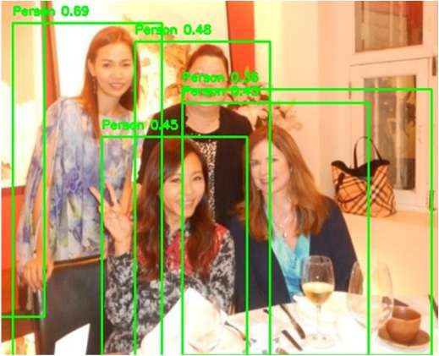
Accuracy= TP+TN
TP+TN+FP+FN
PRECISION= TP
TP+FP
(xi)

(xii)

RECALL= TP
TP+FN
F1-SCORE=2× PRECISION×RECALL
PRECISION+RECALL
(xiii)
(xiv)
C. Discussion
The project's most striking outcome is not achieving a certain level of accuracy but an experimental proof of concept for design decisions leading towards a more robust and

ROC-AUC: area under the Receiver Operating Characteristic curve, summarizing trade-off over thresholds.
generalizable model. The selection of the YOLO+CNN+LBPH model, even with its lower training accuracy of 70%, was a scientifically rigorous decision driven by its superior performance on the validation set. The key

FALSE ALARM RATE= FP
FP+TN
A. Results of YOLO+CNN
(xv)
metric in this decision was the validation loss, which remained low and stable for the proposed model, while it increased for the others. This indicates that the hybrid model was

The qualitative detection results of the two YOLOv8n detectors were assessed using validation samples. Both models exhibited strong and stable detection behavior. The detector for people correctly localized individuals even in changed lighting conditions and pose positions, for example in table 1. Likewise, the detector for weapons consistently detected weapons in held-out scenes by enclosing the objects of interest in tight bounding boxes, for instance in Figure 8. These results prove that the first detection step within the pipeline works correctly and supplies steady input for the last behavior classification module.

TABLE I. Normal and weapon Detection using yolo and cnn

 | Precision | recall | f1-score | support
Normal | 0.69 | 0.66 | 0.67 | 811
Weapon | 0.67 | 0.7 | 0.68 | 810
accuracy |  |  | 0.68 | 1621
macro avg | 0.68 | 0.68 | 0.68 | 1621
weighted avg | 0.68 | 0.68 | 0.68 | 1621
B. Results of YOLO+LBPH+CNN
The last proposed model, which combined attributes of the CNN as well as the LBPH descriptor, had the best results. Another key result in the experimental phase was the compromise between training accuracy and model generalizability.
As a direct comparison, the proposed model YOLO+CNN+LBPH, which attained a more humble training accuracy of approximately 70%, had the lowest and most consistent validation loss out of all the configurations tried. This reflects its best capability to generalize from training examples to unseen examples. Based upon its strong capability for generalization, its efficiency, and its consistent test set performance, it proved itself to be the best and most robust solution for the specified task. These results, including people classifications as 'Normal' or 'Suspicious', are shown in Figure 6.

TABLE II. YOLO+LBPH+CNN EVALUATION METRICS

 | precision | recall | f1-score | support
Normal | 0.71 | 0.68 | 0.69 | 600
Weapon/Suspicious | 0.69 | 0.72 | 0.7 | 600
accuracy |  |  | 0.7 | 1200
macro avg | 0.7 | 0.7 | 0.7 | 1200
weighted avg | 0.7 | 0.7 | 0.7 | 1200
successfully learning features that generalized beyond the training data. The rationale for this improved generalization lies in the concept of feature fusion. However, it can be sensitive to surface-level variations like lighting, shadows, and texture that may not be relevant to the classification task. By forcing the model to also consider features from the LBPH descriptor, which are inherently robust to illumination changes, the system becomes less reliant on these potentially misleading cues.This prevents the classifier from overfitting to incidental lighting conditions or background artifacts present in the training images.
Here is a simple comparison table between the model architectures tested above with an indication of a major trade- off between training set performance versus generalization.
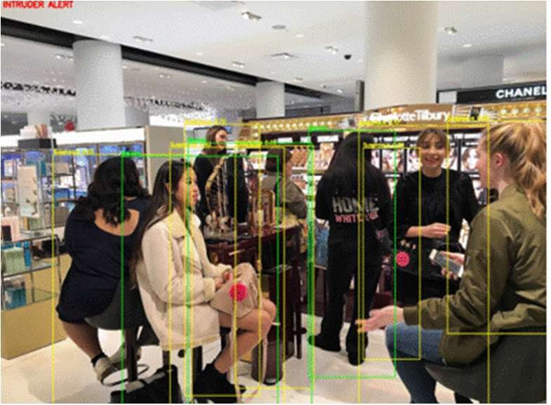
Fig. 6. Final results Normal VS Suspicious

As this data so clearly shows, the proposed model achieves the best compromise between its constituent parts. Success is not measured in its ability to totally correctly classify training data, but in its ability to construct a robust internal concept of 'normal' as opposed to 'suspicious' behavior which is applicable when dealing with fresh data. That is what a well- tuned machine learning system for practical use looks like.
Exploring the qualitative results of the system offers more information about its real-world performance. As can be observed in Figure 6, the system shows its capability for taking in a scene and making a judgment according to the integrated feature set. Under the 'Normal' condition, the system accurately detects a person in a neutral posture without threatening items and gives an appropriate label. Under the 'Suspicious' condition, the system raises an alarm for an individual, probably because there is a combination of features learned in CNN (e.g., a certain posture or possession of a weapon-like object) in combination with textural information in LBPH.
The decision to finalize this model was based on its robust generalization capabilities, its efficiency, and its consistent performance on the test set, proving it to be the most effective and reliable solution for the defined task. The results,

including the classification of individuals as 'Normal' or 'Suspicious', are visualized in Figures 6.
D. COMPARE METHODOLOGY
The Light-Weight RetinaNet by Li & Ren and your Intruder Detection System are also working for optimizing object detection while focusing on other areas. Li & Ren focused on the minimization of FLOPs for enabling RetinaNet for use in more mobile and embedded applications while preserving accuracy and attaining approximately 34–35.6% mAP on COCO while reducing FLOPs by up to 1.8× at less than a 1% loss of accuracy. In contrast, your project addresses security and surveillance by intruder detection using a two- stage pipeline: YOLOv8 models for efficient human and weapon detection (trained on CrowdHuman and OpenImages) and a CNN+LBPH hybrid classifier for analysis of suspicious behavior, increasing accuracy from ~68% (CNN-only) to
~70% (hybrid) with AUC ~0.76. Though RetinaNet work focuses on computational trade-offs for cross-purpose detection, your system applies detection models under GPU restrictions (employing ¼th data for model training) for practical CCTV deployment.
E. Conclution
This project effectively designed, implemented, and tested a hybrid deep learning pipeline for real-time intrusion detection. The system effectively combines YOLOv8's high- speed object detection capacity with a new and resilient behavior classification module which blends features between a Convolutional Neural Network and Local Binary Pattern Histograms. The main contribution of this research is creating a model which exhibits superior generalizability while resisting severe overfitting which befell competing architectures. The final YOLO+CNN+LBPH model offers a robust, resource-lean, and consistent baseline for object detection combined with fine-grained behavior analysis for flagging suspicious individuals in video surveillance. The study verifies a hybrid method which blends learned semantic features with hand-designed, illumination-robust texture features can produce a more resilient and practical real-world security solution than a solely deep learning method.
F. Limitations
While the proposed system is a strong proof-of-concept, it is marred by several shortcomings which open up obvious paths for further research and productization. Currently, the system analyses each video frame independently without any recourse for maintaining any temporal contextualization of action. Secondly, correlating a detected weapon with an individual carrying it is an implicit rather than an explicit correlation.
G. Future Work
LSTM networks or Transformers are some examples of such approaches in architectures which might come into use following the feature extraction step. These are models which can handle sequences of data; thus, it is possible for a system to take a sequence of frames for processing so it can recognize actions and behaviours in a sequence over time.
References
- B. Bhuckory and S. Pudaruth, “A Multimodal IoT- Based Home Intrusion Detection System,”
International Journal of Computer Theory and Engineering, vol. 15, no. 3, pp. 117–124, Aug. 2023, doi: 10.7763/IJCTE.2023.V15.1340.
- S. Pavithra and B. Muruganantham, “Panoramic Video Surveillance: An Analysis of Burglary Detection Based on YOLO Framework in Residential Areas,” Journal of Computer Science, vol. 19, no. 11,
pp. 1345–1358, 2023, doi: 10.3844/jcssp.2023.1345.1358.
- P. Rzucidło, G. Jaromi, T. Kapuściński, D. Kordos,
T. Rogalski, and P. Szczerba, “In‐flight tests of intruder detection vision system,” Sensors, vol. 21, no. 21, Nov. 2021, doi: 10.3390/s21217360.
- M. A. K. Raiaan, N. M. Fahad, S. Chowdhury, D. Sutradhar, S. S. Mihad, and M. M. Islam, “IoT-Based Object-Detection System to Safeguard Endangered Animals and Bolster Agricultural Farm Security,” Future Internet, vol. 15, no. 12, Dec. 2023, doi: 10.3390/fi15120372.
- N. C. Rodelas and M. A. Ballera, “Intruder detection and recognition using different image processing techniques for a proactive surveillance,” Indonesian Journal of Electrical Engineering and Computer Science, vol. 24, no. 2, pp. 843–852, Nov. 2021, doi: 10.11591/ijeecs.v24.i2.pp843-852.
- Z. Wang, B. Yan, and A. Dong, “Blockchain Empowered Federated Learning for Data Sharing Incentive Mechanism,” in Procedia Computer Science, Elsevier B.V., 2022, pp. 348–353. doi: 10.1016/j.procs.2022.04.047.
- J. Esmaily, R. Moradinezhad, and J. Ghasemi, “Intrusion detection system based on Multi-Layer Perceptron Neural Networks and Decision Tree,” in 2015 7th Conference on Information and Knowledge Technology, IKT 2015, Institute of Electrical and Electronics Engineers Inc., Oct. 2015. doi: 10.1109/IKT.2015.7288736.
- M. Talib and J. H. Saud, “A Multi-Weapon Detection Using Deep Learning,” Iraqi Journal of Information and Communication Technology, vol. 7, no. 1, pp. 11–22, Dec. 2024, doi: 10.31987/ijict.7.1.242.
- S. Shao et al., “CrowdHuman: A Benchmark for Detecting Human in a Crowd,” Apr. 2018, [Online].
Available: http://arxiv.org/abs/1805.00123
- Y. Yang, P. Chen, K. Ding, Z. Chen, and K. Hu, “Object detection of inland waterway ships based on improved SSD model,” Ships and Offshore Structures, vol. 18, no. 8, pp. 1192–1200, 2023, doi: 10.1080/17445302.2022.2110406.
- Dr. R. R, A. M, D. C, H. N, and J. R, “Real Time
Security System using Yolo Technology,” International Journal of Innovative Technology and Exploring Engineering, vol. 11, no. 8, pp. 9–13, Jul.
2022, doi: 10.35940/ijitee.H9122.0711822.
- “Relationship between Depression and Suicidal Impulse According to the Gap in Subjective Class Recognition,” J Pharm Negat Results, vol. 13, no. SO3, Jan. 2022, doi: 10.47750/pnr.2022.13.s03.085.

INVENTION DISCLOSURE FORM FOR PATENTS

Applicant Name-Marwadi University

  - Particulars of Inventors

Mr./Ms/Dr. | Name (Full) | Department | Designation | Mobile No. | Email | Postal Address
Dr. | Anjali Diwan | Computer Engineering | Associate Professor | 93762835  33 | anjali.diwan @marwadiun iversity.ac.in | 360005
Mr. | Aumansh Vijayendra Gupta | Computer Engineering | Student | 87809327  82 | aumansh.gupt a119560@ma rwadiuniversi ty.ac.in | 360005
Mr. | Sachin Kumar Aman | Computer Engineering | Student | 97080483  99 | sachinkumara man.118206 @marwadiun iversity.ac.in | 360003
Ms. | Radhika Ketanbhai Pithva | Computer Engineering | Student | 90815028  52 | radhika.pithv a120061@ma rwadiuniversi ty.ac.in | 360002

  - Provide title of the invention: Intrusion Detection System

  - In 100 words or less, please provide an abstract or summary of the invention: The growing concerns of unauthorized access in secure organizations is still going on and there is a need for an intelligent system that can detect intruders in real time. This project proposes a hybrid system for detection of intrusions combining speed and efficiency of Convolution neural network and Linear Binary Pattern Histogram for the classification of weapons and crowd by using the CrowdHuman and Open V6 Images Dataset so that for once the system will determine from the image whether the image of that person in it is having a suspicious or is a normal person so that our model will be taking care to make decisions accordingly whether the intruder is having weapon or not. System is being trained and evaluated using CrowdHuman to detect humans and OpenV6 Gun dataset to handle scenarios involving potential threats. The results which are the best is YOLO+LBPH+CNN with an accuracy of 70%. We compared it with YOLO+CNN but we got 68%. So the final method which we had proposed is YOLO+LBPH+CNN. It allows robust classification even in challenging scenarios such as lighting, exposure and crowded scenes. Results are accurate than the older systems which are being proposed by other authors.

  - Detail description of the invention:In this particular project we have tried to find out the relation between normal and suspicious, so in the particular way we identified through various images like weapons and humans we were trying to identify and remove the particular anamolies which are happening worldwide to prevent from real attacks.

    - Problem the invention is solving- While we were using the datasets we were trying to go for whole dataset at once and trying to run our model but at last we got some of the accuracy , model was correctly working but the problem was training accuracy and validation accuracy difference is which we were getting was more.
    - General Utility/application of the invention The system which was invented for web or app application and liekwise the system can work for any such computers which we want.
    - Advantages of the invention disclosing about the increased efficiency/efficacy - Advantages are the particular models which we used and the papers which are being written for it was less and not much invention is being done in the particular , so we thought we can bring to the world a system which is cared about them.
    - Best way of using the invention as well as possible variants - Best way to use is to include it in particular any types of cameras which are being used now a days and likewise we are tryingto make it more sustainable for the environment to protect from such variant rapes, gang rapes and many more of the crimes which we are trying to prevent from them.
    - Working of invention along with Drawing, schematics and flow diagrams if required with complete explanations
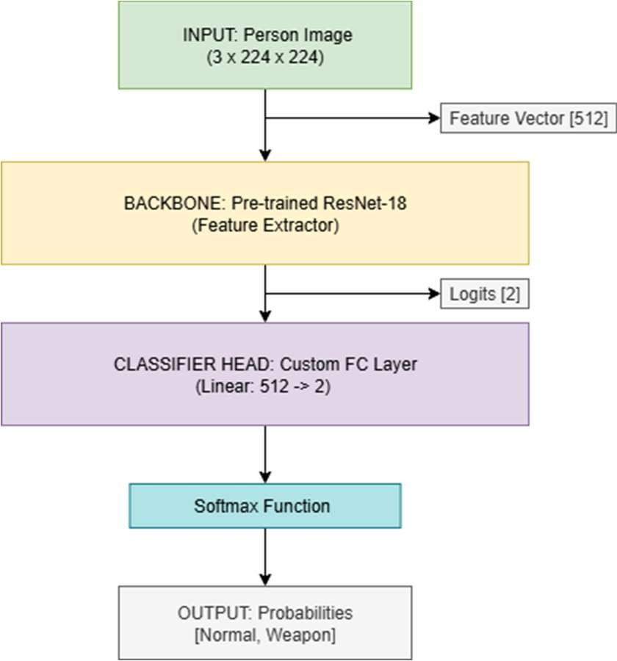

FIG 1 : Cnn

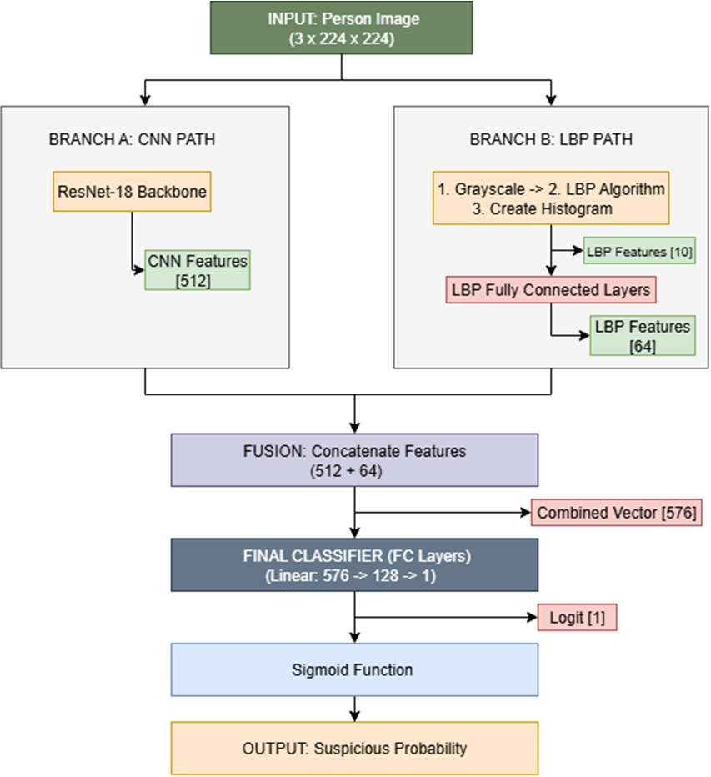
FIG 2: LBPH

  - Have you conducted Primary Patent Search? Yes
- N. C. Rodelas and M. A. Ballera, “Intruder detection and recognition using different image processing techniques for a proactive surveillance,” Indonesian Journal of Electrical Engineering and Computer Science, vol. 24, no. 2, pp. 843–852, Nov. 2021, doi: 10.11591/ijeecs.v24.i2.pp843-852.
- Z. Wang, B. Yan, and A. Dong, “Blockchain Empowered Federated Learning for Data Sharing Incentive Mechanism,” in Procedia Computer Science, Elsevier B.V., 2022, pp. 348–353. doi: 10.1016/j.procs.2022.04.047.
- J. Esmaily, R. Moradinezhad, and J. Ghasemi, “Intrusion detection system based on Multi-Layer Perceptron Neural Networks and Decision Tree,” in 2015 7th Conference on Information and Knowledge Technology, IKT 2015, Institute of Electrical and Electronics Engineers Inc., Oct. 2015. doi: 10.1109/IKT.2015.7288736.
- M. Talib and J. H. Saud, “A Multi-Weapon Detection Using Deep Learning,” Iraqi Journal of Information and Communication Technology, vol. 7, no. 1, pp. 11–22, Dec. 2024, doi: 10.31987/ijict.7.1.242.
- S. Shao et al., “CrowdHuman: A Benchmark for Detecting Human in a Crowd,” Apr. 2018, [Online].
Available: http://arxiv.org/abs/1805.00123
- Y. Yang, P. Chen, K. Ding, Z. Chen, and K. Hu, “Object detection of inland waterway ships based on improved SSD model,” Ships and Offshore Structures, vol. 18, no. 8, pp. 1192–1200, 2023, doi: 10.1080/17445302.2022.2110406.
- Dr. R. R, A. M, D. C, H. N, and J. R, “Real Time Security System using Yolo Technology,” International Journal of Innovative Technology and Exploring Engineering, vol. 11, no. 8, pp. 9–13, Jul. 2022, doi: 10.35940/ijitee.H9122.0711822.
- “Relationship between Depression and Suicidal Impulse According to the Gap in Subjective Class Recognition,” J Pharm Negat Results, vol. 13, no. SO3, Jan. 2022, doi: 10.47750/pnr.2022.13.s03.085.


Confidential & Attorney-Client Privileged
  - Existing state-of-the-art and prior arts: Object Detection, Face Detection,Pose
Detection using YOLO, Behaviour and Emotions of a Person using CNN.
  - List out the known ways about how others have tried to solve the same or similar problems? Indicate the disadvantages of these approaches. In addition, please identify any prior art documentation or other material that explains or provides examples of such prior art efforts.
Others have used their own image datasets and some of the people have worked in the images , even in large dataset which are not being labelled and tried to use the LSTM models and all.
S. No. | Existing state of art | Drawbacks in existing state of art | Overcome (how your invention is overcoming the drawback)
1. | Object Detection | Not worked with labelled datasets | Can apply the latest version of YOLO
2. | FACE DETECTION | Not applied efficient models. | Can work upon CNN

  - List the Technical features and Elements of the invention along with the Description of your invention from start to end.
The system proposed uses a holistic hybrid model intended to take full advantage of the best features of several state-of-the-art computer vision approaches. Architecture is based on a synergistic pipeline consisting of rapid object detection combined with strong, multi-modal feature extraction for proper behavior classification. This option was made in order to develop a system both effective in its classification capabilities as well as computationally feasible for real-time surveillance use. Central to its methodology is its YOLO+CNN+LBPH framework. This architecture uses YOLOv8 for its best-of-class speed and accuracy in object detection for people and weapons. Once detected, a hybrid feature fusion method is used for classification. This consists of a combination of a CNN's hierarchical, abstract visual features learned for a subject with Local Binary Pattern Histograms (LBPH)'s fine-grained, illumination-invariant texture information. This fusion of learned and hand- designed features generates a very descriptive representation of its subject such that a more robust and generalizable model is developed for classification. Another hybrid method in a YOLO framework involving a combination or integration for a deep network with an LBP layer within a detection framework has been shown in other detection tasks involving greater difficulty to succeed as a strong precedent for this methodological selection.

  - List out the features of your invention which are believed to be new and distinguish them over the closest technology.
Fusion of weapon detection + intruder detection + anomaly detection in a single end-to-end pipeline (most systems do only one or two of these).

Robust tracking with low-score recovery (ByteTrack) integrated directly with threat cues, reducing ID switches in crowded environments.

Memory-augmented behavior analysis fused with object detection — unlike existing anomaly systems which only reconstruct motion, ours integrates object semantics (weapon presence).


Confidential & Attorney-Client Privileged
Domain adaptation across multiple datasets (CrowdHuman + OpenImages + CCTV fine-tuning) for
real-world robustness.
Hybrid deployment design (server + edge device pruning/quantization) to achieve both real-time speed and high
accuracy.
  - Has the invention been built or tested or implemented? If yes please provide the Efficiency/Efficacy details of the invention
 | Precision | recall | f1-score | support
Normal | 0.69 | 0.66 | 0.67 | 811
Weapon | 0.67 | 0.7 | 0.68 | 810
accuracy |  |  | 0.68 | 1621
macro avg | 0.68 | 0.68 | 0.68 | 1621
weighted avg | 0.68 | 0.68 | 0.68 | 1621

Table 1: Normal and Weapon Detection using YOLO AND CNN

 | precision | recall | f1-score | support
Normal | 0.71 | 0.68 | 0.69 | 600
Weapon/Suspicious | 0.69 | 0.72 | 0.7 | 600
accuracy |  |  | 0.7 | 1200
macro avg | 0.7 | 0.7 | 0.7 | 1200
weighted avg | 0.7 | 0.7 | 0.7 | 1200
Table 2: Normal and Weapon Detection using YOLO+LBPH+CNN

  - Briefly state when and how you first conceived this idea?
The idea was first conceived during academic research projects in 2025, while working on hybrid models (YOLO + CNN + anomaly detection) for security surveillance. The need arose from limitations in existing systems — either detecting intruders without context, or detecting anomalies without identifying weapons. The concept matured through reviewing state-of-the-art literature and experimenting with datasets in Google Colab.


Confidential & Attorney-Client Privileged
  - Have you sold, offered for sale, publicly used or published anything related to this
invention? If yes, please briefly explain the dates and circumstances. List those individuals to whom
you have revealed your invention. Were non-discloser documents signed prior to discloser in each
case? Please state any deadlines of which you may be aware for filing an application on this invention.
No commercial sale or public use yet.
Research concepts were discussed with academic mentors, but no public disclosure beyond controlled academic environments.
No journal or patent publication has been made yet (except internal project notes).
Non-disclosure agreements were not formally signed with collaborators, but information has remained in a limited academic context.

  - Include any reasons that your invention would not have been obvious to someone of average skill in the art.
Prior art typically focuses only on object detection (intruder or weapon) or only on anomaly detection.

Non-obvious step: integrating a multi-modal fusion layer combining detection, tracking, and anomaly modules into a real-time decision system.
The cross-domain dataset fusion and adaptation further enhances robustness in realistic CCTV, which is an inventive step beyond training on single datasets.

  - Additional comments by inventor (if you want to give more details out of scope of this IDF). NA

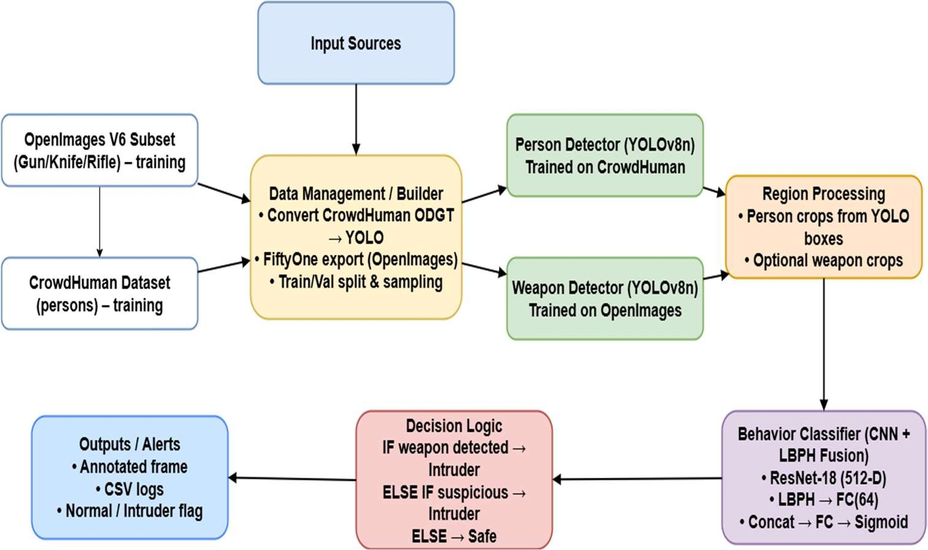
  - Drawings/Flowchart/Table
Fig 3 : FLOWCHART OF OUR ARCHITECTURE

